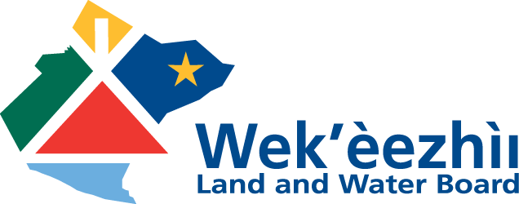
Box 32, Wekweètì, NT X0E 1W0
Tel: 867-713-2500 Fax: 867-713-2502

#1-4905 48th Street, Yellowknife, NT X1A 3S3
Tel: 867-765-4592 Fax: 867-765-4593
www.wlwb.ca

Regulatory Specialist
Yellowknife, Northwest Territories

The Tlicho People have strong, traditional ties to the land, water, and wildlife, so ensuring responsible use of land and water for the benefit of Tlicho People is of paramount importance.

The Regulatory Specialist is responsible for coordinating submissions made to the Board, managing public reviews, conducting environmental impact assessments, liaising with government, industry, First Nations, and other stakeholders, managing various projects, and carrying out technical reviews.

If you have environmental and technical experience and are interested in joining a high-performing team in a fast-paced, progressive, and dynamic environment, we encourage you to apply.

The successful applicant will have a relevant degree and demonstrate the following competencies in their cover letter and resume:
- strong technical writing ability;
- strong written and oral communications skills;
- project and time management;
- cultural awareness; and
- an understanding of relevant environmental legislation.

The starting salary for this position ranges from $83,007 to $89,324 per year plus a comprehensive benefits package that includes over $10,000 per year in allowances. Interested candidates should submit their cover letter and resume by Sunday, July 7, 2019 to:
Attn: Allan Twissell at NorthWays Consulting
RE: WLWB Regulatory Specialist Competition
e-mail: northwayscareers@northwestel.net

Only those applicants selected for an interview will be contacted. Thank you for your interest in this competition.

